e

l Federal Office

I for Migration

I and Refugees

The stages of the German asylum procedure

An overview of the individual procedural steps

and the legal basis englisch



Asyl und Fluchtlingsschutz

**Who is a “refugee”?**

The term “refugee” is often used in everyday language as a general synonym for people who have been displaced, but the law on asylum only understands it as covering recognised refugees in accordance with the Geneva Refugee Convention, that is individuals who are given refugee protection once their asylum proceedings have been completed. There are however three more forms of protection where a right to asylum can be granted, if they are applicable. As the authority responsible for implementing the law on asylum, the Federal Office distinguishes more precisely, that is between the following groups of individuals:

**Asylum-seekers:**

individuals who intend to file an asylum application but have not yet been regis­tered by the Federal Office as asylum applicants.

**Asylum applicants:**

asylum applicants whose asylum proceedings are pending and whose case has not yet been decided on.

**Persons entitled to protection and persons entitled to remain:** individuals who receive an entitlement to asylum, refugee protection or subsidiary protection, or who may remain in Germany on the basis of a ban on deportation.

Foreword

Asylum is a right that is protected by the Constitution in Germany. People who are displaced from other parts of the world, fleeing from violence, war and terror, are to find protection in our country.

When they arrive in Germany, displaced persons reach safe ground, frequently after been in danger for years. Having said that, they only have certainty as to whether they and their families may remain here permanently and work when their asylum application has been finally decided on.

The examination of asylum applications is one of the most important tasks performed by the Federal Office for Migration and Refugees. This is a responsible, demanding task, given that decisions are taken on people, in complex procedures, taking diverse competences and stringent legal frameworks into account.

In each individual case, highly-trained decision-makers from the Federal Office with considerable skills and experience decide whether an asylum application is justified, and whether one of the four grounds for protection enabling a person to remain in Germany applies.

This brochure will provide you with an overview of the most important aspects of the asylum procedure, such as applicants' personal interview, the steps taken in the decision-making process, recent activities to optimise procedures, as well as the place which the activities take up within a European context.

More detailed information regarding procedures, statutory instruments and the legal basis, recent asylum data or studies on the topic of asylum and refugee protection, can be found on the web at **[www.bamf.de/asyl+fluechtlingsschutz](http://www.bamf.de/asyl+fluechtlingsschutz)**[.](http://www.bamf.de/asyl+fluechtlingsschutz)

Contents

**Foreword 5**

1. **From arrival to the asylum procedure 8**
   1. Arrival and registration 10
   2. Initial distribution and accommodation 12
   3. The competent reception facility 13
   4. Personal asylum applications 14
   5. Examining the Dublin procedure 16
   6. The personal interview 18
   7. The decision of the Federal Office 21
   8. Appeals against the decision 29
   9. The outcome of the asylum proceedings 31
2. **Processing the application at the Federal Office 34**
   1. Arrival centres and AnkER facilities 36
   2. Decision-makers 38
   3. Procedure management and quality assurance 40
3. **Unaccompanied minors 42**
4. **Particularities of the asylum procedure 46**
   1. Safe countries of origin 48
   2. The airport procedure 49
5. **European cooperation 50**
   1. The Common European Asylum System - CEAS 52
   2. The European Asylum Support Office - EASO 52

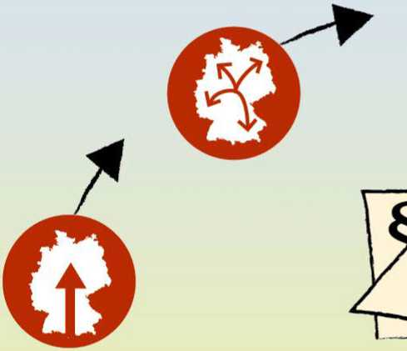

From arrival to the asylum procedure



All asylum-seekers arriving in Germany must report to a state organisation directly on arrival or immediately thereafter. They can do this as soon as they reach the border or later within the country. Anyone already report­ing as seeking asylum on entry approaches the border authority. This authority then sends asylum-seekers on to the closest initial reception centre. Anyone who does not make a request for asylum until they are in Germany can report to a security authority (such as the police), an immigration authority, a reception facility or directly to an arrival centre or AnkER facility. Only then can the asylum procedure begin.

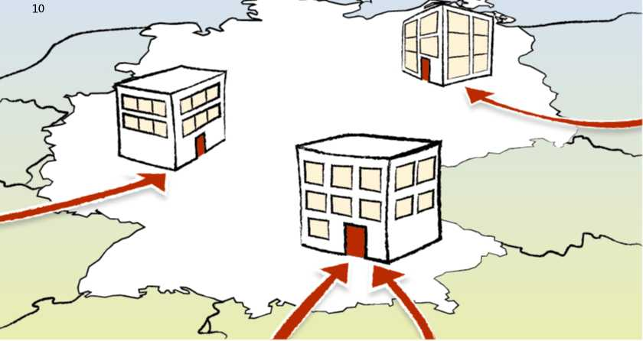

1. Arrival and registration

All individuals reporting as seeking asylum in the Federal Republic of Germany are registered. Personal data are recorded at this point. All applicants are photographed; the fingerprints are also taken of people aged over 14.

The recorded data are stored centrally in the “Central Register of Foreigners”.

All public agencies which subsequently need them for their respective tasks have access to these data to the extent that they need them for their respective remits.

In a first step, the new data are compared with those already available in the Central Register of Foreigners, as well as with those of the Federal Criminal Police Office.

It is examined amongst other things whether an initial application, a follow-up applica­tion or possibly a multiple application has been made. It is also investigated using a Europe-wide system (Eurodac) whether another European state might be respon­sible for carrying out the asylum procedure.

Asylum-seekers receive a proof of arrival *(Ankunftsnachweis)* at the reception facility or arrival centre which is responsible for them to prove that they have registered. As the first official document, the proof of arrival serves to document the entitlement to reside in Germany. And what is equally important is that it constitutes an entitlement to draw state benefits, such as accommodation, medical treatment and food.

**The Central Register of Foreigners *(Auslanderzentralregister)***

The data collected during registration are stored in the Central Register of Foreigners (AZR). The AZR is a nationwide, personal file which is centrally managed by the Federal Office. It contains information on people from abroad who are or were resident in Germany. All the immigration authorities work with these data in performing their tasks.



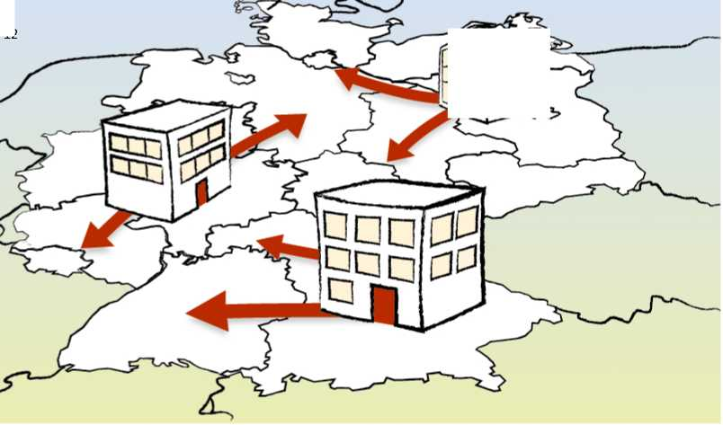

1. Initial distribution and accommodation

First, all asylum-seekers are received in nearby reception facilities of the Federal *Land* in question. Such a facility may be responsible for temporary as well as longer-term accommodation.

Allocation to a specific reception facility is decided according to the specific branch office of the Federal Office processing the asylum-seeker's respective country of origin: Asylum-seekers can be accommodated in reception facilities for up to six months, or until their application is decided on. They can however also be allocated to another facility during this period under certain circumstances, for instance for family reunification.

**EASY - The quota system for fair distribution**

The EASY quota system (Initial Distribution of Asylum-Seekers) is orientated in line with the “Konigstein Key”. The distribution quota is calculated on an annual basis, and determines what share of asylum-seekers are received by each Federal *Land.* This ensures suitable, fair distribution among the Federal *Lander.*

The current distribution quotas can be found on the web at**[www.bamf.de](http://www.bamf.de)**[.](http://www.bamf.de)



1. The competent reception facility

The competent reception facility is responsible for providing food and board for asylum-seekers. They receive benefits in kind at subsistence level during their stay and a monthly amount of money to cover their everyday personal needs. The nature and amount of the benefits are regulated by the Asylum-Seekers' Benefits Act *(Asylbewerberleistungsgesetz).* These include basic benefits for food, housing, heating, clothing, healthcare and personal hygiene, as well as household durables and consumables, benefits to cover personal daily requirements, benefits in case of sickness, pregnancy and birth, as well as individual benefits which depend on the particular case.

Benefits for asylum applicants are also provided in the follow-up accommodation (such as in collective accommodation or even a private apartment). More information is available from the responsible immigration authority.



1. Personal asylum applications

A personal application is filed with a branch office of the Federal Office (an arrival centre or an AnkER facility). An interpreter is available for this appointment. Applicants are informed of their rights and duties within the asylum procedure. They furthermore receive all the important information in writing in their native language.

The personal data are recorded during the application procedure, if this has not already taken place. Applicants are obliged to prove their identity if they are able to do so. Documents accepted include a national passport, as well as other personal documents such as birth certificates and driving licences. The Federal Office uses physical and technical document examination to assess the original documents.

The application is made in person as a rule. A written asylum application may only be filed in special cases, for instance if the individual in question is in a hospital or has not yet reached the age of maturity.

**Residence obligation *(Residenzpflicht)***

Once their asylum application has been filed, applicants receive a certificate of their permission to reside *(Aufenthaltsgestattung).* This certificate serves as documenta­tion vis-a-vis state agencies that they are asylum applicants, and proves that they are in Germany lawfully. Permission to reside is territorially restricted to the district (residence obligation) in which the responsible reception facility is located.

Persons with poor prospects to remain are obliged to live in the reception facilities until the decision is taken. If their asylum application is turned down as “manifestly unfounded” or “inadmissible” (see also “Appeals against the decision”), this obliga­tion for people to reside in a particular place then applies until they leave the country. They are not permitted to work during this period, and they may only temporarily leave the area designated in their permission to reside if they have permission from the Federal Office.

Persons with good prospects to remain may initially also only remain in the area designated in their permission to reside. They too need permission if they would like to temporarily leave this area. The residence obligation ceases to apply to them after three months. The residence area is then expanded to cover the entire country.





1. Examining the Dublin procedure

The Dublin procedure is used for determining the Member State responsible prior to the actual examination of the asylum application. The Dublin procedure is used to determine the responsibility for carrying out the asylum procedure in an EU Member State. The Dublin III Regulation lays down criteria and procedures to be applied when determining the Member State responsible for examining an application for international protection. It applies in all 28 EU Member States, as well as in Norway, Iceland, Liechtenstein and Switzerland. The purpose of the Dublin procedure is for each asylum application which is lodged in the territory of the Member States to be examined under the substantive law of one country only.

**The steps in the Dublin procedure in the Federal Office**

After the application has been submitted to the competent branch office of the Federal Office, the personal interview takes place, the content of which is used by the Federal Office to determine the competent Member State and to examine impediments to deportation in the Dublin procedure. The applicant is informed in this interview about the procedure and asked to state any reasons why he or she should not be transferred to another Member State.

If there are indications that another Member State is responsible, the file to initiate the Dublin procedure is forwarded to the Dublin Centre of the Federal Office which holds responsibility there. If the examination carried out by the Dublin Centre reveals that another Member State could be responsible for processing the asylum applica­tion, a “transfer request” is addressed to the Member State concerned. If the Member State approves the transfer request, the Federal Office finds that the asylum appli­cation is inadmissible in Germany and orders deportation to the responsible Member State.

The individual in question may bring an action against this decision and apply to the administrative court that has jurisdiction to order suspensive effect. Transfer to the Member State is not permissible before a judicial ruling has been handed down on the application for suspensive effect to be ordered.

The transfer must take place within six months of the agreement of the Member State. If the individual in question is in custody, the transfer period is 12 months.

If the individual in question is a fugitive, the transfer period is 18 months. If a request is made for suspensive effect to be ordered, the transfer period is interrupted until a decision is taken on that request.

The actual enforcement of the transfer is the responsibility of the immigration authorities and of the Federal Police. This also includes setting a date for the transfer.

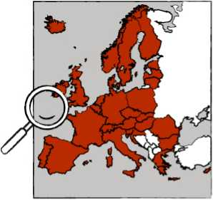



1. The personal interview

The personal interview is the applicant's most important appointment within his/her asylum procedure. Organisations providing aid or charitable associations therefore offer advice when it comes to preparing for the interview. The Federal Office has also been implementing group information and individual counselling sessions on the asylum procedure at the AnkER facilities since August 2018 (see p. 37).

It is the “decision-makers” at the Federal Office who are responsible for holding the interviews. They invite applicants to attend this appointment, where an interpreter will also be on hand.

Applicants absolutely must attend this appointment, or they must state in good time why they are unable to attend. If they do not do so, their asylum application can be turned down or the proceedings discontinued.

The interviews are not public, but they may be attended by an attorney or by a repre­sentative of the United Nations High Commissioner for Refugees (UNHCR), and by a guardian in the case of unaccompanied minors. It is fundamentally possible for another person enjoying the applicant's trust to attend as an advisor. This individual must be able to identify himself or herself, and may not personally be in the asylum procedure.

The objective of the interviews is to learn of the individual reasons for flight, to obtain more information and to resolve any contradictions. To this end, the decision-makers are familiar with the circumstances prevailing in the applicants' countries of origin.

Applicants are afforded sufficient time during the interview to present their respective reasons for taking flight. They describe their biographies and situations, tell of their travel route and of the persecution which they have personally suffered. They also assess what would await them were they to return to their country of origin. They are obliged to state the truth at all times and to provide any evidence which they have been able to obtain. These may be photographs, documents from the police or other authorities, and possibly also medical reports.

The descriptions are interpreted and minutes are taken, and are then translated back for the applicants after the interview. This enables them to add to what they have said, or to make corrections. They are then presented with the minutes for them to approve them by signing them.

**Participation by the UNHCR**

The United Nations High Commissioner for Refugees (UNHCR) monitors in order to ensure compliance with the Geneva Refugee Convention. If the UNHCR requests information for his work, the Federal Office provides it. The UNHCR may also attend interviews in the asylum procedure. He may furthermore inspect the decisions of the Federal Office and their reasoning in order to perform his tasks.

**Identity checks**

In order to improve identity determination, the Federal Office has introduced assistance systems as part of the “Integrated identity management: plausibility, data quality, and security aspects (IDM-S)” programme. These systems provide supporting information when it comes to carrying out factual investigations. This provides decision-makers with additional indications that can make it easier for them to determine the facts of the case.

* Image biometrics - Analysing biometric images enables automatic face recog­nition based on unique individual biometric features. Image biometrics also serve as a further means of identification in addition to fingerprint matching.
* Name transliteration and analysis - Name transliteration involves a standardised conversion (transliteration) from Arabic to Latin script.
* Speech biometrics - A voice recording is used to biometrically recognise the (major) dialect spoken by the applicant. This information allows conclusions to be drawn as to the country of origin, and can provide valuable information for use in the interview.
* Evaluating mobile data media - Analysing mobile data media helps to deter­mine identity and origin on the basis of metadata stored on the mobile phone (including geodata).
* These assistance systems, which are based on modern data analysis methods, enable the information on asylum-seekers collected during the asylum proce­dure to be immediately checked for plausibility. This leads to better data quality. Should any doubts remain as to applicants' identity, the Federal Office carries out an examination using language and text analyses with the involvement of language experts. Such cases can be reported to the Federal Office's own Security division where appropriate. The division works closely with the Joint Extremism and Counter-Terrorism Centre (GETZ) and with the Joint Counter­Terrorism Centre (GTAZ). What is more, it carries out an automatic data comparison with the security authorities within the bounds imposed by privacy laws.



1. The decision of the Federal Office

The Federal Office decides on the asylum application on the basis of the personal interview and of a detailed examination of documents and items of evidence.

The fate of the individual applicant is decisive. The decision is reasoned in writing, and is served on the applicant or the legal representative, as well as on the competent immigration authorities.

**Possibilities for decision-making**

The Federal Office examines each asylum application on the basis of the German Asylum Act *(Asylgesetz)* as to whether one of the four forms of protection - entitlement to asylum, refugee protection, subsidiary protection or a ban on deportation - applies. Only when none of these forms of protection can be considered is the asylum application rejected.

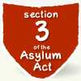

Acknowledgement of entitlement to asylum

Award of refugee protection

Award of subsidiary protection

Imposition of a ban on deportation

**The four forms of protection**

Entitlement to asylum

Accordingly, persons who would be subject to a serious human rights violation should they return to their country of origin are entitled to asylum and deemed to have been persecuted on political grounds because of their rac[e[1] [2],](#bookmark0) nationality, political opin­ion, fundamental religious conviction or membership of a particular social group.

**§ The legal basis and consequences**

**Article 16a para. 1 of the Basic Law**

* residence permit for three years
* settlement permit possible after three or five years if other precondi­tions are met, such as the ability to make a secure living and adequate knowledge of German
* unrestricted access to the labour market - gainful employment permitted
* entitlement to privileged family reunification (see p. 27)

**Safe third countries**

Recognition of entitlement to asylum is ruled out if an individual enters via a safe third country. The German Asylum Act *(Asylgesetz)* defines the Member States of the European Union, as well as Norway and Switzerland, as safe third countries.

**The right of asylum**

Refugee protection

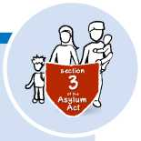Refugee protection is more extensive than entitlement to asylum, and also applies to persecution by non-state players. On the basis of the Geneva Refugee Conven­tion, people are regarded as refugees who, because of a well-founded fear of being persecuted by state or non-state players for reasons of race, religion, nationality, political opinion or membership of a particular social group, are outside their country of origin and nationality, or as stateless individuals are outside of their country of habitual residence. These criteria also apply if they are unable or, because of a well- founded fear, are unwilling to avail themselves of the protection of their country of origin.

**§ The legal basis and consequences**

**Section 3 subs. 1 of the Asylum Act *(AsylG)***

* residence permit for three years
* settlement permit possible after three or five years if other precondi­tions are met, such as the ability to make a secure living and adequate knowledge of German.
* unrestricted access to the labour market - gainful employment permitted
* entitlement to privileged family reunification (see p. 27)



Subsidiary protection

People are entitled to subsidiary protection who put forward substantial grounds for the presumption that they are at risk of serious harm in their country of origin and that they cannot take up the protection of their country of origin or do not wish to take it up because of that threat. Serious harm can originate from both governmental and non-governmental players.

The following are regarded as constituting serious harm: the imposition or enforce­ment of the death penalty, torture, inhuman or degrading treatment or punishment, a serious individual threat to the life or integrity of a civilian as a result of arbitrary force within an international or domestic armed conflict.

**§ The legal basis and consequences**

**Section 4 subs. 1 of the Asylum Act (*AsylG*)**

• residence permit for one year

• if extended: two more years in each case

• settlement permit possible after five years (the duration of the asylum

procedure is included) if other preconditions are met, such as the ability to make a secure living and adequate knowledge of German

* unrestricted access to the labour market - gainful employment permitted
* no entitlement to privileged family reunification (see p. 27)

**Reasons for not qualifying for protection**

The three forms of protection mentioned above cannot be considered if reasons for not qualifying apply. These include: If an individual has committed a war crime or a serious non-political criminal offence outside Germany, has breached the goals and principles of the United Nations, is to be regarded as a risk to the security of the Federal Republic of Germany, or constitutes a danger to the public because he/she has been finally sentenced to imprisonment for a felony (*Verbrechen*) or a particularly serious misdemeanour (*Vergehen*).

National ban on deportation

A person who is seeking protection may not be returned if return to the destination country constitutes a breach of the European Convention for the Protection of Human Rights and Fundamental Freedoms (ECHR), or a considerable concrete danger to life, limb or liberty exists in that country.

A considerable concrete danger can be considered to exist for health reasons if a return would cause life-threatening or serious diseases to become much worse. This is not contingent on the healthcare provided in the destination state being equivalent to that available in the Federal Republic of Germany. Adequate medical treatment is also deemed to be provided as a rule if this is only guaranteed in a part of the destination country.

If a national ban on deportation is issued, a person may not be returned to the country to which this ban on deportation applies. Those concerned are issued with a residence permit by the immigration authority.

A ban on deportation can however not be considered if the person concerned could depart for another country, and it is reasonable for them to be called on to do so, or if they have not complied with their obligations to cooperate.

**§ The legal basis and consequences**

**Section 60 subs. 5 of the Residence Act (*AufenthG*)**

**Section 60 subs. 7 of the Residence Act**

• residence permit for at least one year

• repeated extensions possible

• settlement permit possible after five years (the duration of the asylum procedure is included) if other preconditions are met, such as the ability to make a secure living and adequate knowledge of German

• employment possible - permission must be obtained from the immigration authority



Family asylum applies to members of a family. What this means is that, if a “prin­cipal person entitled” has been recognised as entitled to asylum, his or her family members who are in Germany are also granted asylum on application. Spouses and registered partners, minor, unmarried children, the parents of a minor, unmar­ried person for the purpose of care and custody, another adult who has personal custody of a minor, unmarried person, as well as the minor, unmarried siblings of a minor, are regarded as family members for the purposes of family asylum. This arrangement also applies to persons entitled to protection to whom refugee protection or subsidiary protection has been granted. Persons are excluded with regard to whom a national ban on deportation has been determined.

**Born in Germany**

If a child is born in Germany after the parents have filed an asylum application, the legislature provides for the possibility of a separate asylum procedure in order to protect the children, subject to specific preconditions. For this purpose, the par­ents, at least one of whom is in the asylum process, or the immigration authority inform the Federal Office that the birth has taken place. The asylum application is hence automatically regarded as having been filed in the interest of the newborn child. The parents can submit separate grounds for asylum for their child. If they do not do so, the same grounds apply as to the parents. It is also possible to take legal action against a rejection by the Federal Office in these instances.

If the parents' application has already been decided on, children who were born in Germany receive their own notice. The following applies if the application is rejected: In order to protect the child, minor children may not and will not be returned separately from their parents if the application is turned down.

**Family reunification**

Persons to whom entitlement to asylum or refugee status has been granted are entitled to privileged family reunification: This covers spousal as well as child reunification. The appropriate application for this must be filed with the Federal Foreign Office within three months after the entitlement to protection has been granted.

**Persons entitled to subsidiary protection**

Family reunification of close family members to join persons entitled to subsidiary protection has been possible again since 1 August 2018. This however applies to a limited contingent of 1,000 persons per month.

**Humanitarian reasons are paramount**

The new provision does not imply any legal entitlement to family reunification. The competent authorities are to decide who receives a residence permit on humanitarian grounds. The criteria applied are the duration of the separation, the age of the children, any serious illnesses, and the specific endangerment in the country of origin. In addition, integration-related aspects must also be taken into account. Spouses, minor children and parents of minors can apply for family reunification as a matter of principle. Siblings are not similarly entitled. Family reunification is also ruled out in the event of a marriage that took place during flight.

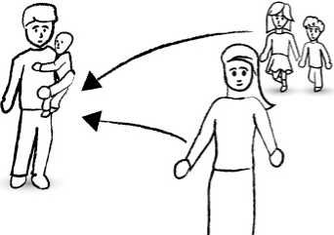

**Inadmissible asylum applications**

Even if Germany is responsible for examining the asylum application after the Dublin procedure has been concluded, an asylum application may be rejected by the Federal Office as inadmissible. This takes place, for example, in all cases in which applicants have already been through the asylum procedure in another country and have already been granted protection there. It is then not possible to obtain protection in Germany for a second time. These countries can be the Member States of the EU, Norway or Switzerland.

If a refugee has been transferred from a refugee camp in what is known as the relocation procedure (see European Asylum Support Office) to another European country, he or she must file an asylum application there. Any application that may have been filed in Germany then becomes inadmissible.

If an asylum application that was lodged by the applicant has already been rejected once, a further application is inadmissible if no new grounds for asylum have arisen since the most recent decision. It is immaterial in such cases whether the first application was rejected in Germany (follow-up application) or in another country (second application).

**Follow-up applications and second applications**

It is also possible to obtain protection in Germany by filing a follow-up or second application. However, since the previous reasons for flight have already been decided on, applicants must now demonstrate that new reasons have arisen since the most recent decision was issued. If there are new reasons, the Federal Office carries out a new asylum procedure and examines the new reasons.



1. Appeals against the decision

Applicants receive a negative notice together with a notice of intention to deport if the conditions for none of the four forms of protection - entitlement to asylum, refugee protection, subsidiary protection or a ban on deportation - apply.

When an asylum application is turned down, a distinction is made between two types of rejection: outright rejection and rejection as “manifestly unfounded”. If the rejection is outright, the individual in question is set a deadline of 30 days in which to leave the country, whereas if the asylum application is rejected as “manifestly unfounded”, the deadline period for leaving is only one week.

In each case, appeals are available to those concerned. They can take court action against the decision of the Federal Office. The action must be lodged within a short period of time as a matter of principle. It is helpful to appoint legal counsel in most cases. The written notice points out the appeals available and the deadlines. This is known as the notice of appeals *(Rechtsbehelfsbelehrung).* The possibility to take legal action also exists in the case of a positive notice - unless refugee protec­tion has been granted.

The court then examines the decision which the Federal Office has taken. If it con­cludes that the preconditions for granting protection actually do apply, it rescinds the notice and obliges the Federal Office to provide protection. If the rejection is confirmed with regard to all forms of protection, the action is rejected and the foreigner remains obliged to leave the country.

If the individual does not voluntarily comply with their obligation to leave the coun­try, this can also take place coercively, the respective immigration authority being responsible for the return. This also applies if no court action is brought. If a return is not possible, the immigration authority can issue temporary suspension of depor­tation *(Duldung),* or indeed a residence permit.





1. The outcome of the asylum proceedings

The final decision of the Federal Office - the conclusion of the asylum proceedings - is followed either by a right of residence or by a right to remain, or by an obligation to depart. The respective immigration authorities are responsible for matters related to termination of residence.

**Issuing residence permits**

Persons who are entitled to asylum receive a three-year residence permit from the immigration authority that is responsible for them. The same applies if refugee status has been granted. An indefinite settlement permit can be issued after three years at the earliest under certain circumstances, such as the ability to make a secure living and adequate knowledge of German, if the Federal Office does not initiate the revo­cation procedure.

Persons who are entitled to subsidiary protection receive a residence permit which is valid for one year and can be extended for two more years in each case. A settle­ment permit can be issued after five years at the earliest (the duration of the asylum procedure is included) if other preconditions are met, such as the ability to make a secure living and adequate knowledge of German.

If a national ban on deportation has been handed down, a person may not be returned to the country to which this ban on deportation applies. Those concerned receive a residence permit if the conditions for this are satisfied (see National ban on deportation). The residence permit is issued for at least one year, and can be repeatedly extended. The same rules apply to issuing a settlement permit as to people who are entitled to subsidiary protection.

**The revocation and withdrawal procedures**

The law requires the Federal Office to revoke the recognition of entitlement to asylum and the award of refugee status if the preconditions for them no longer apply. This is the case for instance if the persecution situation has permanently changed, or if it no longer applies, and those concerned would no longer face danger should they return. The protection status is withdrawn if it was granted on the basis of incorrect information or failure to reveal essential facts.

The possibility of withdrawal must furthermore be examined if there are reasons for not qualifying, such as a war crime or a serious non-political criminal offence outside Germany, a breach of the goals and principles of the United Nations, a risk to the security of the Federal Republic of Germany, or finally sentencing to imprisonment for a felony *(Verbrechen)* or a particularly serious misdemeanour *(Vergehen).*

The Federal Office examines within the “standard assessment” whether the pre­conditions for revocation or withdrawal are satisfied. Individuals who have been granted protection by the BAMF within the asylum procedure have been obliged since December 2018 to participate in this examination themselves if the Federal Office considers this to be necessary and reasonable. It only informs the competent immigration authority of the result of this examination if the conditions for revoca­tion or withdrawal of protection status are met. Even if no revocation or withdrawal takes place on the occasion of the standard assessment, it is not impossible for the protection status to be revoked at a later date.

It is the respective immigration authority which decides on the continued residence.

**Termination of residence**

When an asylum application is turned down, an obligation to leave the country is the consequence. The respective immigration authorities are responsible for returns. The latter can however temporarily suspend a return and issue a temporary suspension of deportation *(Duldung)* or a time-limited residence permit if there are obstacles to the return which the Federal Office was not able to take into account in its decision.

It is also possible to return on a voluntary basis at any time. The German authorities - that is the Federal Government and the Lander - offer various return programmes for those interested in returning.

Further information on voluntary return is available on the Internet at **[www.returningfromgermany.de](http://www.returningfromgermany.de)**[.](http://www.returningfromgermany.de)

**Bans on entry and residence for asylum applicants whose applications have been turned down**

A statutory ban on entry and residence - the “re-entry ban” - comes into force for asylum-seekers who do not leave the country voluntarily after their asylum appli­cations have been turned down. The job of the Federal Office here is to set a time limit on bans on entry and residence for rejected asylum applicants. The individual circumstances (genuine interests) are taken into account here. The immigration authorities are responsible for implementing bans on entry and residence.

**Nationals of safe countries of origin and follow-up applications**

A special feature applies to nationals from “safe countries of origin”. If their asylum applications are turned down, the Federal Office additionally orders a ban on entry and residence and decides on its duration. It also becomes effective if the individual leaves the country voluntarily.

**The consequences of a ban on entry and residence**

If a ban on entry and residence starts to apply to an individual, this is entered in the INPOL national police information system and in the Central Register of Foreigners for the individual in question. When individuals are checked on entry, entry can be refused. Persons who are found to be illegally resident in Germany can even be detained. As a matter of principle, the ban on entry and residence does not apply only to Germany, but to the entire Schengen area.



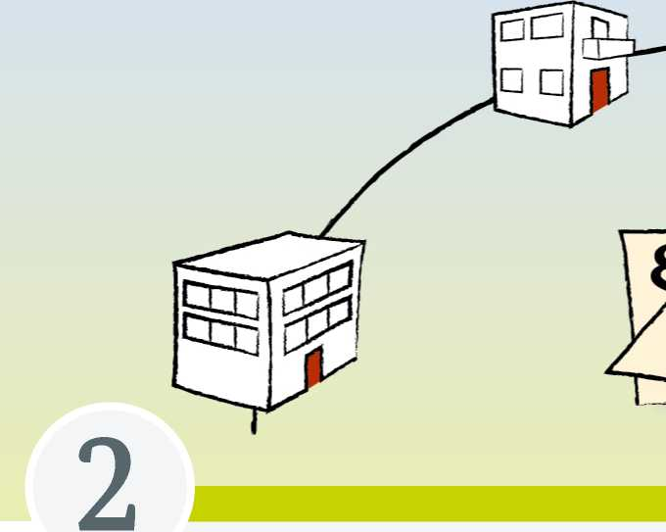

Processing the application at the Federal Office

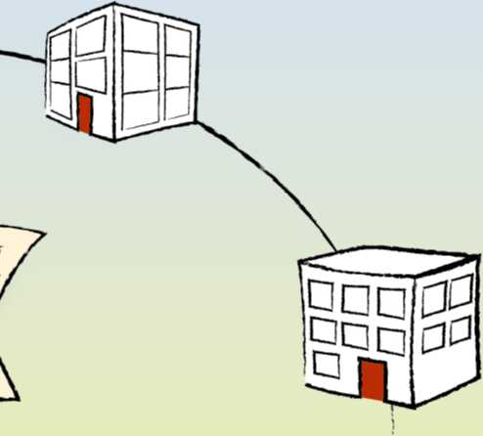

Efficient workflows at the locations all over the country, specialist skill-building for staff, cooperation with other authorities, procedure management as well as quality assurance in processing the applica­tions at the Federal Office, help continually improve quality and the observance of legal certainty.



1. Arrival centres and AnkER facilities

**Arrival centres**

The arrival centres are the central entry point when it comes to the asylum procedure. It is in the arrival centres that all the steps are carried out which are necessary for the asylum procedure. This includes the medical examination by the *Lander,* the recording of the personal data and the identity check, the application, the interview and the Federal Office's decision on the asylum application, as well as initial integration measures, such as “initial orientation courses”. The local employment agency also provides initial advice on access to the labour market.

Integrated refugee management is used to store the processes of the authorities involved - from registration in the respective Federal Land, examining the state of health, through to the notice on the decision - in a nationwide core data system, and hence to improve cooperation.

Asylum-seekers are already informed whilst their applications are being processed about attending integration courses offered by the Federal Office at the respective place of residence.

In order to facilitate possible access to the labour market, counsellors from the Federal Employment Agency collect initial data from the applicants on site in the arrival centres. This information is then available to the employment agencies and job centres all over the country.

**AnkER facilities**

The fundamental concept underlying the arrival centres has been refined with the new arrival, decision and return (AnkER) facilities, operating as modern service fa­cilities. The central element underlying the AnkER concept is to bundle all functions and responsibilities, from arrival to asylum application and the decision, through to distribution among the municipalities, first measures preparing for integration or indeed returning asylum applicants. All stakeholders who are directly involved in the asylum process are represented on the ground in the AnkER facilities. As a rule, these are the reception facilities of the Land, the Federal Office for Migration and Refugees, the immigration authorities, the administrative courts, the youth welfare offices and the Federal Employment Agency. No rigid concept is stipulated for the design of the centres - the *Lander* can set the priorities here that are particularly important to them.

**Asylum procedure counselling (AVB)**

The BAMF has been offering a two-stage model of AVB in the AnkER facilities since August 2018. This includes:

* general information on the asylum procedure in group discussions for all asylum-seekers prior to and building on their application,
* where necessary, an individual asylum procedure counselling in individual interviews during the entire asylum process.

AVB aims to promote the quality, efficiency and compliance with the rule of law of the asylum procedure. The implementation of the individual asylum procedure counselling by the BAMF is parallel and subsidiary to that of the other agencies. The BAMF employees assigned to carry out AVB receive special training. They oper­ate independently of the asylum sector, and do not process the asylum applica­tions of applicants whom they have advised.



1. Decision-makers

The decision-makers at the Federal Office are part of the general, non-technical administrative service. Their task, namely to examine asylum applications, comprises both the important personal interview, as well as the subsequent decision on the asylum applications. The technical prerequisites for performing this task include both comprehensive knowledge of the law on asylum and on immigration, as well as detailed knowledge of the political situation in the applicants' countries of origin. Furthermore, certain soft skills such as a mastery of customary interview techniques, culturally-sensitive empathy and intercultural skills, are included in the fundamental prerequisites for deployment as a decision-maker.

**Skill-building and technical prerequisites**

A contemporary basic and further training concept is implemented in the Federal Office's Centre for Qualification. Staff are comprehensively trained by experienced instructors and prepared for the asylum procedure. Once the fundamentals of the law on asylum and interviewing and questioning techniques have been imparted, new decision-makers are trained in practical cases. Because the asylum procedure in Germany is subject to constant change, including as a result of constant changes in policy, both the new colleagues and experienced staff members are obliged to attend regular training. This is also where the “specially-commissioned case-officers” are trained.

**Specially-commissioned case-officers**

Specially-commissioned case-officers are specially-trained decision-makers for interview procedures among particularly vulnerable groups of individuals. These include unaccompanied minors, victims of torture, victims of trauma and persons persecuted because of their gender, as well as victims of trafficking in human beings. The specially-commissioned case-officers are at the disposal of their superiors and colleagues as contacts over and above their own tasks in processing applications.



1. Procedure management and quality assurance

Ongoing procedure management and quality assurance are needed to ensure uni­form workflows.

**Procedure management**

The procedures are managed via various instruments such as official instructions and work guidelines. In the shape of guides, these also include internal orientation aids for asylum-seekers' main countries of origin. These for instance make it easier to assess the situation where circumstances are comparable. The guides also cover topics such as domestic flight alternatives, group persecution and family liability. They however never replace an individual examination and assessment of the asylum applications. This is additionally carried out in each individual case by the decision-makers.

**Quality assurance**

Quality assurance covers all the steps in the procedure, from lodging the applica­tion to serving the notice, and thus takes a holistic approach. The quality control of interviews and notices is based on the four-eyes principle, which is applied in the form of short summaries. In addition, randomly-selected procedures are subjected to further quality control by the central Quality assurance Division.

Procedural tools are used with the aim of complying with the quality standards and ensuring uniform decision-making practice. They include official instructions, text manuals, work guidelines and quality manuals. In addition, further training courses are offered for decision-makers.

Regular exchanges (discussions and workshops) also take place with the UNHCR and with European partner authorities as part of quality assurance.

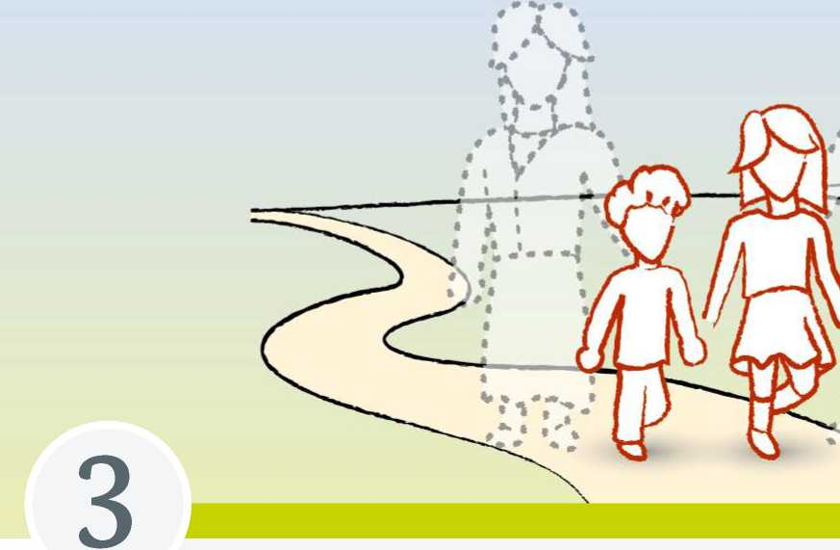

Unaccompanied minors



• * « •» L—X

Special rules apply to unaccompanied minors when they apply for asylum and in processing.

Children and juveniles aged under 18 are regarded in the German asylum procedure as being minors. If they enter a Member State of the EU without being accompanied by an adult who is responsible for them, or if they are left there unaccompanied, they are regarded as unaccompanied minors.

**Initial taking into care and initial screening**

Unaccompanied minors are first of all taken into care by the youth welfare office that has local responsibility. This provisional taking into care ensures that they are accommodated with a suitable person or in a suitable facility. Suitable persons can be relatives or foster families, whilst suitable facilities are as a rule “clearing houses” specialising in caring for unaccompanied minors, or youth welfare facilities.

“Initial screening” is also carried out when such minors are provisionally taken into care. As well as the general examination of the state of health, the age of the minors is established. The methods that are used for this range from simply estimating age through physical examinations to X-ray tests. The responsible youth welfare office also estimates whether the implementation of the subsequent distribution procedure might endanger the child's best interests in physical or psychological terms. The pos­sibility of family reunification with relatives living in Germany is also examined in this context. If close social ties exist with other unaccompanied minors, the youth welfare office examines whether it makes sense to accommodate them together.

**Distribution and further taking into care**

A nationwide distribution procedure exists in order to ensure that the unaccompanied minors are accommodated, supplied, cared for and supported in a manner that is suited to the child's best interests. After this distribution, the youth welfare office to which the minors have been assigned is responsible for their further taking into care.

Here too, they are either accommodated with a suitable person - relatives or foster families - or in a suitable facility - such as a clearing house.

**The appointment of a guardian**

A guardian or curator must be appointed for unaccompanied minors. The Family Court decides who ultimately assumes the guardianship. Guardianship as a rule lasts until the person attains majority. The age of majority is orientated in this process towards the law in the minor's country of origin, and not towards German law. If there­fore a minor does not attain the age of majority under this law until after turning 18, as is the case for instance in Togo (majority at 21), the guardianship also does not end until this time.

The subsequent clearing procedure entails the initiation of further steps under the law on youth assistance or on residence. This includes clarifying the residence status. It is decided on this basis whether an asylum application is lodged. If such an applica­tion would not be promising, the competent immigration authority may also issue a temporary suspension of deportation (*Duldung*). If this cannot be considered either, the immigration authority will discuss other possibilities under the law on residence. If an asylum application is to be lodged, the Federal Office is responsible for the implementation of the asylum procedure.

**The asylum application**

The national provisions apply to determining the age of majority within the asylum application. This means that once they have reached the age of 18, asylum-seekers need to lodge their own asylum application as they are regarded as being of age, irrespective of the law applying in their country of origin. The guardian can however continue to accompany the asylum application in this case. Asylum-seekers aged under 18 are regarded as not having legal capacity within the asylum application. This means that unaccompanied minors may not file an asylum application with the Federal Office by themselves. In such cases, the asylum application has to be filed in writing by the youth welfare office or guardian. If it is lodged by a guardian, a “certificate of appointment” ( *Bestallungsurkunde* ) needs to be forwarded.

**The interview and the decision in the asylum procedure**

Since unaccompanied minors are regarded as a particularly vulnerable group of individuals enjoying special guarantees for their asylum procedure, their asylum ap­plications are taken care of by specially-commissioned case-officers who have been specially trained to take a sensitive approach. These procedural guarantees include for instance the determination that the interview does not take place until after a guardian has been appointed and is held as a matter of principle in the presence of the latter.

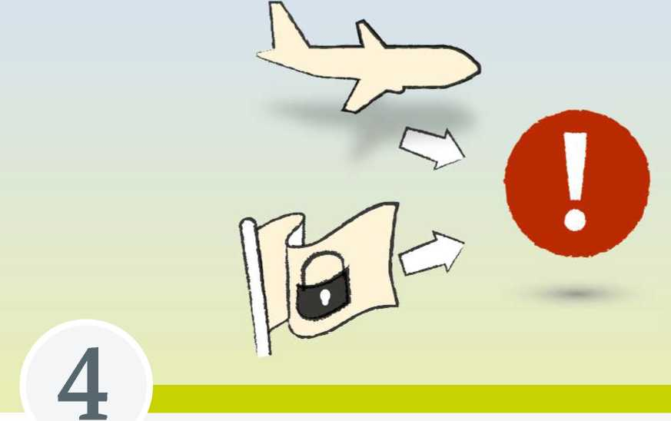

Particularities of the asylum procedure



— /I

Special procedures apply in the asylum proceedings to applicants from safe countries of origin and those who enter the country by air.

1. Safe countries of origin

The law defines countries as safe countries of origin if it is possible to presume on the basis of the democratic system and of the general political situation that no state persecution is to be feared there as a rule, and that the state in question can provide protection against non-state persecution as a matter of principle. Protection against non-state persecution means for instance that there are legal and administrative provisions in place to provide protection for the population, and that these are also made accessible to all and applied. The “default presumption” then applies that there is no risk of persecution.

Applicants from safe countries of origin are interviewed in person on their grounds for asylum, regardless of the default presumption. They are afforded the opportunity during the interview to submit facts or evidence documenting that they are none­theless at risk of persecution in their home country, in derogation from the default presumption. It is by no means out of the question for them to be granted protec­tion. If the information is inadequate to refute the default presumption, the asylum application is to be denied as “manifestly unfounded”. The appeal deadlines for such rejections are curtailed.

Which countries are currently considered to be safe countries of origin in Germany can be found on the topical page “Asylum and Refugee Protection” [(](http://www.bamf.de/asyl)**[www.bamf.de/asyl](http://www.bamf.de/asyl)**[).](http://www.bamf.de/asyl)

1. The airport procedure

A special procedure, known as the “airport procedure”, applies should people attempt to enter the country by air and apply for asylum.

This entails the asylum procedure being carried even out before the Federal Police decide whether an individual may enter the country, that is while they are still in the transit area, if the applicants are unable to identify themselves with a valid passport or replacement passport after having orally requested protection, or if they come from a safe third country.

**Special arrangement**

Since the airport procedure is operated subject to the “principle of immediacy”, the Federal Office must interview applicants without undue delay, and must decide on the asylum application within two days. The Federal Office has the possibility to approve the application, so that permission to enter the country is simultaneously given by the Federal Police, or the Office rejects the asylum application as “manifestly unfounded”. If the application is turned down, the Federal Police can refuse to permit applicants to enter.

Following on from a rejection, an application can be filed for temporary legal protec­tion. Applicants then receive legal advice from an independent lawyer free of charge within three days. If the administrative court approves the emergency application or has not ruled on it within 14 days, the asylum applicant may enter the country. This means that the airport procedure has a potential total duration of 19 days. The asy­lum applicants must however remain in the airport transit area until a final ruling has been handed down. If the appeal is turned down, they are then sent back either to the place where their flight originated, or to their country of origin.

The airport procedure is only implemented at airports which can accommodate asylum applicants on the airport complex. This currently applies at Berlin-Schonefeld, Dussel­dorf, Frankfurt/Main, Hamburg and Munich airports.





European cooperation



Many people travel to the European Union in order to escape from war and persecution or for economic reasons. The EU's obligation to help those in need of protection is entrenched in the Charter of Fundamental Rights, as well as in the Treaty on the Functioning of the European Union. Joint legal provisions and practical support measures for the Member States have been developed in order to counter this challenge as well as possible: The Common European Asylum System (CEAS). The European Asylum Support Office (EASO) is furthermore to strengthen practical cooperation among the EU Member States on asylum.

1. The Common European Asylum System - CEAS

The EU has been working on the Common European Asylum System (CEAS) since 1999. A number of legal acts have been adopted in asylum and refugee policy since then which today form the basis for a region of refugee protection and solidarity in the EU. The core element of the Common System today is the harmonisation of the standards of protection and reception across the EU. The latter are intended to ensure that asylum-seekers are given international protection under the same conditions in the entire EU.

Since the number of people who apply for asylum in the EU every year is however not spread evenly among the Member States, it is a major concern to jointly shoulder responsibility for protecting displaced persons. A contribution towards a fair dis­tribution among the Member States is also made by the reform proposals within the Dublin regulations, which are adjusted to the changing situation where necessary.

1. The European Asylum Support Office - EASO

The European Asylum Support Office (EASO) is to strengthen practical cooperation among the EU Member States on asylum and help implement the Common European Asylum System. It especially supports Member States whose asylum and reception systems are under particular pressure. The EASO has developed an early warning sys­tem allowing it to analyse trends in asylum at regular intervals and to enable Member States to prepare better for migration by asylum-seekers. It coordinates asylum support teams and measures aimed at rapidly analysing asylum applications or providing necessary reception capacities.

The EASO also eases the flow of information on asylum-related issues between the Member States. The collection of information on asylum-seekers' countries of origin is coordinated in a joint portal. This also includes a central analysis of the informa­tion and reporting on information that has been collected. Another important task is to provide support in the re-settlement of individuals who are under international protection outside and within the EU (resettlement and relocation). The Office further­more offers courses for staff from asylum, justice and administrative authorities of the Member States.

Further information on the EASO is available on the web at**[easo.europa.eu](http://easo.europa.eu)**[.](http://easo.europa.eu)

|  |  |  |  |  |
| --- | --- | --- | --- | --- |
|  |  | | |  |
|  |  | □ |  |  |
| i . |  |  | 1 _ |
|  | □ | | |  |
| i . |  |  |  | 1 |
|  |  |  |  |  |
|  | |  | 7 | |

Imprint

**Published by:**

Federal Office for Migration and Refugees

D-90461 Nurnberg

**Edited by:**

Public relations, internal communication Division, Veranstaltungsmanagement,

OOMMEN OH! HOPPE - Buro fur Kommunikation, Cologne

**Valid as of:** 2/2019; 2nd updated version

**Printed by:** Silber Druck oHG, Lohfelden

**Design:** KonzeptQuartier® GmbH, Furth

**Picture credits:** Materna GmbH, Dortmund

**Reference source:**

Publications office of the Federal Office for Migration and Refugees [www.bamf.de/publikationen](http://www.bamf.de/publikationen)

You can also download this publication as a barrier-free PDF document. This publication is made available by the Federal Office for Migration and Refugees as part of its public relations work. The publication is distributed free of charge, and is not intended for sale. It may not be used by political parties, election campaigners or election workers during an election campaign for the purpose of election advertising. This applies to Bundestag, Landtag and local elections, as well as to elections to the European Parliament.

**[www.bamf.de](http://www.bamf.de)**

1. In accordance with Article 16a of the Basic Law *(Grundgesetz - GG)* of the Federal Republic of Germany, persons persecuted on political grounds have the right of asylum. The right of asylum has constitutional status as a fundamental right in Germany. At its core, it serves to protect human dignity, but it also protects life, physical integrity, freedom and other fundamental human rights. It is the only fundamental right to which only foreigners are entitled.
2. The term “race” is used in accordance with the wording of the Geneva Refugee Convention.